RBA: A Semi-Automatic Tool for Generating Customised R2RML Mappings
Luís Eufrasio T. Neto¹, Vânia Maria P. Vidal¹, Marco A. Casanova², José Maria Monteiro¹
¹ Federal University of Ceará, Fortaleza, CE, Brazil
{vaniap.vidal, luis.eufrasio, jmmfilho}@gmail.com
² Department of Informatics – Pontifical Catholic University of Rio de Janeiro, RJ, Brazil
casanova@inf.puc-rio.br
Abstract. In this paper, we demonstrate RBA (R2RML By Assertion), to automatically generate customized R2RML mappings based on a set of semantic mappings that model the relationship between the relational database schema and a target ontology in RDF. The semantic mappings are specified by a set of correspondence assertions, which are simple to understand. Optionally, the triples resulting from the mapping can be published into a local endpoint SPARQL using an embedded D2RQ Server extension.
Keywords: Linked Data, RDB-to-RDF user interface, R2RML mappings.
- Introduction
The Linked Data initiative [2] promotes the publication of previously isolated databases as interlinked RDF triple sets, thereby creating a global scale data space, known as the Web of Data. However, the full potential of linked data depends on how easy it is to transform data stored in conventional, relational databases (RDB) into RDF triples. This process is often called RDB-to-RDF [12].
There are two main approaches for mapping RDB to RDF: direct mapping and customized mapping. The Direct mapping approach relies on automatic methods that derive ontology from a relational schema and transform data according to that schema. The customized mapping approach lets an expert create a mapping between the relational schema and an existing target ontology that is used to make the transformation into RDF. In this approach, the RDB-to-RDF process can be divided into two steps: mapping generation and mapping implementation. The mapping generation step results in a specification of how to represent RDB schema concepts in terms of RDF classes and properties in a target vocabulary of the designer’s choice. The mapping is conceptual and enables different implementation styles. For example, it can be used to materialize the RDF view or to offer virtual access through an interface that queries the underlying database.
In fact, quite a few tools that support customized mapping have been developed, such as Triplify [1], D2R Server [3, 4], and OpenLink Virtuoso [9, 10]. Early surveys of RDB-to-RDF tools [12, 14] pointed out that the tools typically adopt different and proprietary mapping languages for the mapping process and do not provide a way to easily generate customized mappings between a RDB schema and a given domain ontology.
Recently, the W3C RDB2RDF Working Group proposed a standard mapping language, called R2RML [8], to express RDB-to-RDF mappings. However, R2RML is somewhat difficult to use, which calls for the development of tools to support the definition and deployment of mappings using R2RML. In this demo, we will show RBA a tool to easy the task of generating customized R2RML mappings.
- Generating R2RML Mappings with RBA
In our approach, we use a three-level architecture for mapping RDB to RDF, which is depicted in Figure 1. The exported ontology (E) models the RDF view exported by the data source. The vocabulary of the exported ontology is a subset of the target ontology vocabulary. The middle layer consists in a set of relational view schemas VS, where VS is a direct transformation for the exported ontology E. The views schemas in VS can be implemented as SQL views or R2RML views.
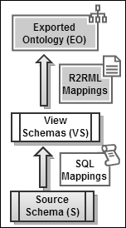  Fig. 1. Three Level Architecture | 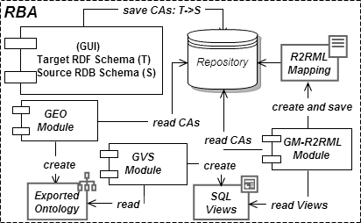  Fig. 2. RBA: main components.
The benefits of using SQL views as a middle layer are twofold: (i) given that VS is a direct transformation of E, the mapping M can be automatically generated based on VS; (ii) it becomes easier to change the R2RML mapping M to accommodate changes to the database schemas.
Figure 2 highlights the main components of RBA. The process for generating R2RML mappings with RBA, consists of four steps:
STEP 1: A typical session with RBA starts with the user loading a source and a target schema into the system. Then, the user can draw correspondence assertions (CA) for specifying the mapping between the target RDF schema and the source relational schema. A correspondence assertion can be: (i) a class correspondence assertion (CCA), which matches a class and a relation schema; (ii) an object property correspondence assertion (OCA), which matches an object property with attributes or paths of a relation schema; or (iii) a datatype property correspondence assertion (DCA), which matches a datatype property with attributes or paths of a relation schema. A GUI facilitates the process of loading the schemas and entering the correspondence assertions.
STEP 2: The GEO module automatically generates the exported ontology, which can be automatically generated based on the correspondence assertions defined in step 1.
STEP 3: The GVS module automatically generates the set of relational view schemas VS, where VS is a direct transformation for the exported ontology E; The views schemas in VS can be implemented as SQL views or R2RML views. In [xx] we present an algorithm that automatically generates VS and the CAs between VS and E. from the process inputs.
STEP 4: The GM-R2RML module automatically generates a R2RML mapping M which maps VS to E. In [xx] we present an algorithm that automatically generates M from the the CAs between VS and E.
An Illustrating Scenario: Consider the two schemas shown in Figure 1

On this section we demonstrate the features of RDB2RDFmb by a running example.
Consider the creation of a Mapping Configuration where user choices the well known FOAF vocabulary as target ontology and the ISWC relational database.
Using the ontology URI and database connection parameters typed by user, the application loads the schema Trees (see Figure 3). The user is able to create term matching’s.
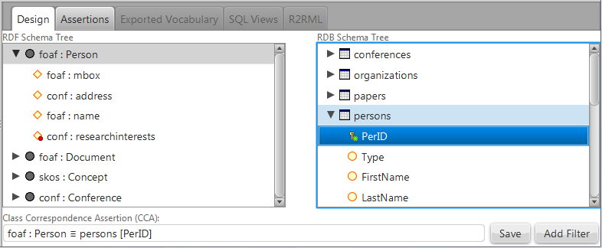
Fig. 3. Class Correspondence Assertion (CA) created matching class foaf:Person with relation persons and choosing attribute PerID to be part of class URI.
After defining a CA user must save it. When a CA is saved, the Assertions Tab is updated as visualized in Figure 4.
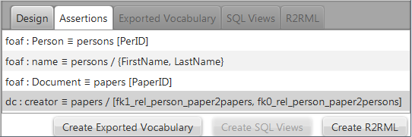
Fig. 4. Assertion Tab holds the list of assertions saved. In this example, we created two CCAs (classes foaf:Person and foaf:Document), one DCA (datatype property foaf:name) and one OCA (object property dc:creator) that refers to an fk path.
In order to create the SQL Views, an Exported Vocabulary is automatically generated when required by the user. See the first Button in Figure 4. Figure 5 shows the exported ontology for our case study. It has the classes mapped with their respective properties.
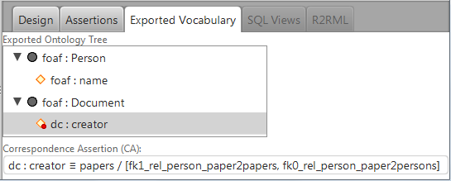
Fig. 5. Exported Ontology showing the classes and properties mapped and the CA for the selected ontology term (dc:creator).
After this, GVS module is able to automatically generate the two views. These views are depicted in Figure 6.
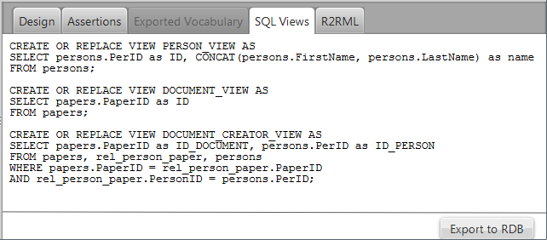
Fig. 6. SQL Views created
At this point, the user should request the creation of the SQL Views into the source RDB. This creation is necessary because the R2RML mapping generated in the last Step will reference these views as logical tables. As the RDB-to-RDF mapping is done by the SQL Views, the resulting R2RML generated is trivial. It is showed in figure 7. Optionally, the user may request the publication of the relational data mapped and the tool will create an endpoint SPARQL based on the D2R extended component.
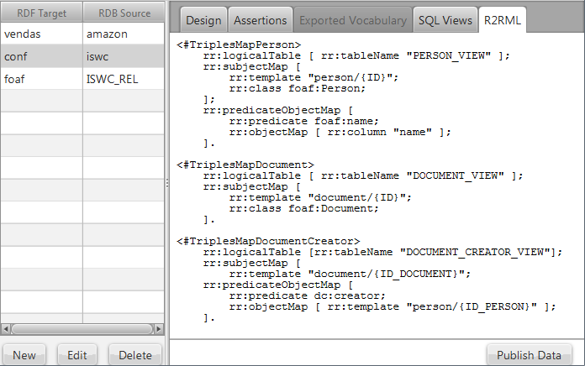
Fig. 7. R2RML mapping generated
References
- Auer, S., Dietzold, S., Lehmann, J., Hellmann, S., and Aumueller, D.: Triplify - Light-Weight Linked Data Publication from Relational Databases. In Proceedings of the 18th International World Wide Web Conference (2009).
- Berners-Lee, T: Linked Data, http://www.w3.org/DesignIssues/LinkedData.html (2006).
- Bizer, C., and Cyganiak, R.: D2R Server – Publishing Relational Databases on the Semantic Web, ISWC (2006).
- Bizer, C.: D2R Map – A Database to RDF Mapping Language, World Wide Web Conference (2003).
- Casanova, M. A., Breitman, K. K., Furtado A. L., Vidal, V. M., Macedo, J. A., Gomes, R. V., Salas, P. E.: The Role of Constraints in Linked Data. OTM Conferences (2) 2011: 781-799.
- Cerbah, F.: Learning highly structured semantic repositories from relational databases. The Semantic Web: Research and Applications pp. 777–781 (2008).
- Cullot,N.,Ghawi,R.,Ye ́tongnon,K.:DB2OWL:AToolforAutomaticDatabase-to-Ontology Mapping, pp. 491–494 (2007).
- Das, S., Sundara, S., and Cyganiak, R.: R2RML: RDB to RDF Mapping Language, W3C Working Draft, http://www.w3.org/TR/r2rml/ (2012).
- Erling,O.,Mikhailov,I.:Rdfsupportinthevirtuosodbms.NetworkedKnowledge-Networked Media pp. 7–24 (2009).
- OpenLink Virtuoso. http://virtuoso.openlinksw.com
- Polfliet, S., Ichise, R.: Automated mapping generation for converting databases into linked data. Proc. of ISWC2010.
- Sahoo, S.S., Halb, W., Hellmann, S., Idehen, K., Thibodeau Jr, T., Auer, S., Sequeda, J., Ez- zat, A.: A survey of current approaches for mapping of relational databases to rdf. W3C RDB2RDF Incubator Group report (2009).
- Sequeda, J.F., Depena, R., Miranker, D.P.: Ultrawrap: Using sql views for rdb2rdf. Proc. of ISWC2009.
- Sequeda, J., Tirmizi, S., Corcho, O., Miranker, D.: DMSurvey Survey of directly mapping SQL databases to the Semantic Web (2011).
- Vidal, V. M., Araujo, V. S., Casanova, M. A.: Towards Automatic Generation of Rules for Incremental Maintenance of XML Views of Relational Data. WISE 2005: 189-202.

